SQL Assignment 4

1) Write a select command that produces the order number, amount, and date for all rows in the Orders table.
--> select Onum,Amt,Odate from Orders;
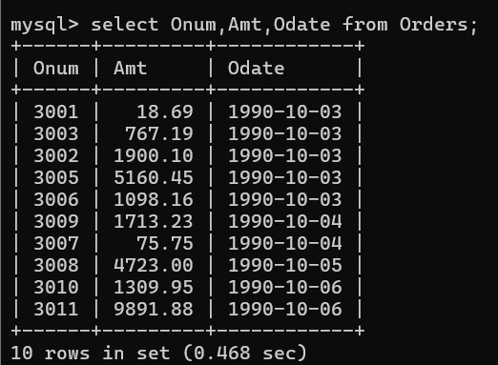
2) Write a query that produces all rows from the Customers table for which the salesperson’s number is 1001.
--> select * from salespeople where Snum = 1001;
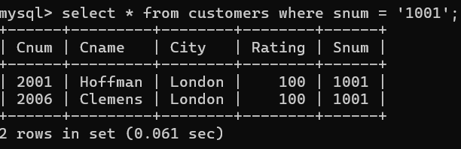

3) Write a query that displays the Salespeople table with the columns in the following order: city, sname, snum, comm.
->select city,sname,snum,comm from salespeople;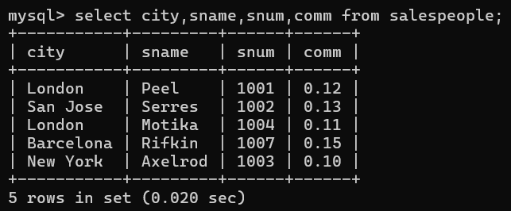
4) Write a select command that produces the rating followed by the name of each customer in San Jose.
-->select city,sname,snum,comm from salespeople;
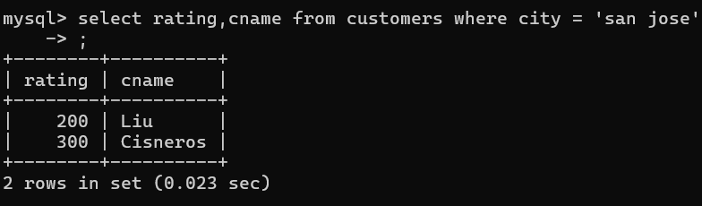

5) Write a query that will produce the snum values of all salespeople (suppress the duplicates) with orders in the Orders table.
--> select distinct snum , Onum from orders;
-->